Joshua Baker – Online diary

8/12/2020

This week I worked with Jamie Smith, (Steve) Yap Hou Yuen and Akash Sroay. This week we had to create a character and a character arc/story for that character. The character also had to be able to fit into a game. We decided on creating our character of the hero’s journey (our character was decided to be the playable character/main protagonist). The reason why we chose this is because everyone was already behind the idea of using this character arc and it was an easy idea to work behind.

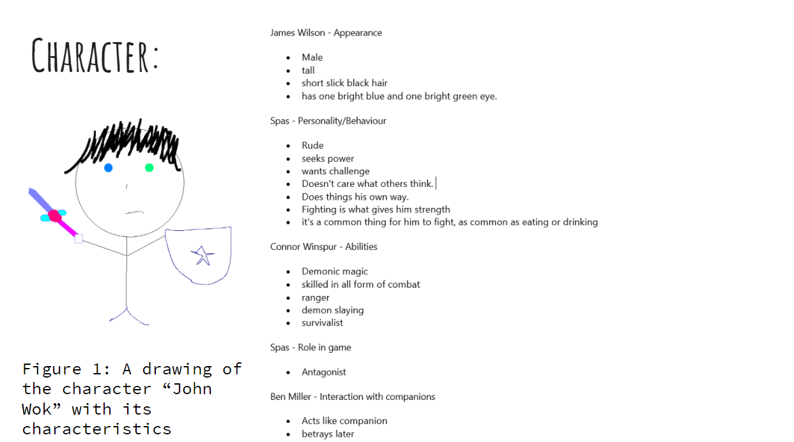

Figure 1: a screenshot of the characteristics we had to make our character around

**The story:**

**Call to adventure:** His village gets destroyed, John Wok and Bill Mill survived! he must flee from home, in fear of their lives. Being targeted by bounty hunters. He has lost everything he has known. Bounty been put up as he had demon blood, but he does not know. Before the father died, he told John wok who his real father is and where he is. John Wok and Bill Mill his best friend set off to find his real father.

**Supernatural aid:** Bill Mill gives him a legendary sword that is super effective against demons. John Wok is super excited and blood hungry with his new amazing sword!

**Threshold:** Finds his real dad who becomes his new mentor. Finds where his dad is. Father decides to train him and then John meets a girl named Sophie Ash. Does not take interest as John is focused on power.

**Abyss (Death and rebirth):** Protagonist gets betrayed by Bill Mill after finding out who they really are, dad dies, almost dies himself becomes a demon (Demonic blood). Loses everything. No sense of who he used to be.

**Transformation:** Finds out who he and his village really were. This gives John Wok a new meaning to his life. Becomes a demon and wants to exact his revenge giving him a purpose to continue in his life. Accepts who he really is and give in to rage and bloodlust.

**Atonement:** John Wok kills his best friend and only friend Bill Mill. But defeated by everything he had to go through. He has given up on who he was and has decided to live a good and honest life. His friends and family are his journey and now that they have both ended for John Wok so too has his journey.

**Return:** After the slaughter of everyone in the capitol, John Wok goes back to Sophie and confesses his love for her. They then return to the village. John Wok begins to build a family with Sophie and rebuilds the village.

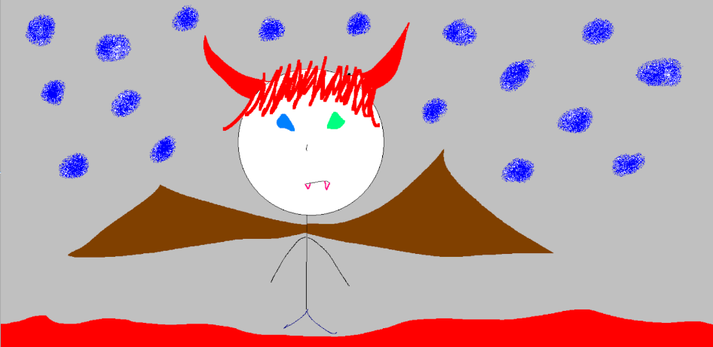Figure 2: second drawing of John Wok

This story concept would work well for open world single player games such as the Witcher and Ghost of Tashima. This game would thrive of 3rd person and I feel that this story can take a lot of inspiration from games such as fallout 4. I feel that if done well it can be really well made, although the quality of our story is certainly not great, it was merely a 30 minuet idea that needed to be presented/get the right idea across to our audience effectively.